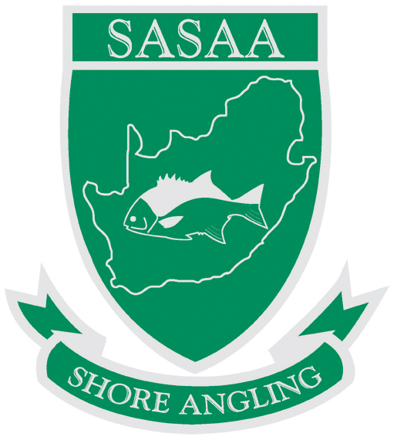
SUID AFRIKAANSE KUSHENGEL ASSOSIASIE
SOUTH AFRICAN SHORE ANGLING ASSOCIATION

President: Pierre du Preez
pdupreez@revan.co.za
Cell: 083 564 2160
Secretary: Frans Claassen
sasaasec@telkomsa.net
Cell: 083 546 7474

SOUTH AFRICAN SHORE ANGLING ASSOCIATION : AFFILIATED REGIONAL MEMBER ASSOCIATIONS AND CONTROLLING BODIES

Boland Shore Angling Association
Chairman: A Krahtz
Email: akrahtz@telkomsa.net
Secretary: D Fouche
Email: debbie.fouche@covidien.com

Border Shore Angling Association
Chairman: C Range
Email: charl_justin.range@daimler.com
Secretary: R Koekemoer
Email: ryankoekemoer@gmail.com

Eastern Province Shore Angling Association
Chairman: R Rautenbach
Email: raute01@vwsa.co.za
Secretary: A Stevens
Email: andre.stormer@gmail.com

Free State Shore Angling
Chairman: G Britz
Email: con-fil@iafrica.com
Secretary: I Steyn
Email: isabel.steyn1@vodamail.co.za

Mpumalanga Shore Angling Association
Chairman: S de Wet
Email: stephen@musketeereng.co.za
Secretary: N de Wet
Email: nelani@lubemasters.co.za

KwaZulu Natal Coast Anglers Union
Acting Chairman: C Groenewald
Email: cgroenewald@cbl.co.za
Secretary: D Nisbet
Email: secretary@kzncau.co.za

Western Province Angling Association
Chairman: T Kemp
Email: Thys.Kemp@bcx.co.za
Secretary: P du Preez
Email: pdupreez@revan.co.za

Zululand Shore Angling Association
Chairman: B Tedder
Email: Barry.Tedder@mondigroup.co.za
Secretary: L Steenkamp
Email: LiezelS@bell.co.za

West Coast Shore Angling Association
Chairman: D Howell
Email: Danny@wkm.co.za
Secretary: S Steenkamp
Email: Sunette.Steenkamp@ZA.Tronox.Com

Gauteng North Shore Angling Association
Chairman: H Pretorius
HPretorius@csir.co.za
Secretary: D de Jager
Email: danie.dejager@crosspe.com

Southern Cape Shore Angling Association
Chairman: J Strauss
Email: scangling@netactive.co.za
Secretary: A Nel
Email: andren@nashuaisp.co.za

Central Gauteng Shore Angling Association
Chairman: M Dowie
Email: martin.dowie@db.com
Secretary: Vacant
Email:

